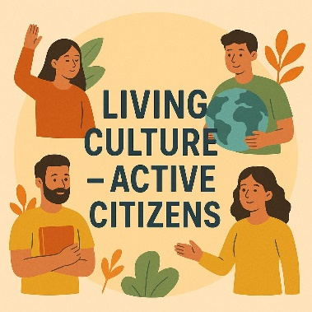 Living Culture, 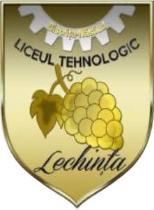
Active Citizens
e-Twinning project
October 2025 – March 2026

Partners Turkey, Romania, Greece,
Aims
This project aims to help students develop active citizenship, democracy, and responsibility by presenting their own cultural values. While discovering different cultures, students will improve respect and tolerance, and they will produce collaborative outcomes such as a Digital Culture Box, folk dance video, cultural festival, and an e-magazine using digital tools.
LTL Team
Students
Bălan Alexandra – VII A Cira Daria- Ariana – VI A
Demian Ioana – VII A Nistea Rania – VI A
Donath Sofia – VII A
Mureșan Iasmina – VII A
Tîrnovan Daria – VII A

Coordinator teacher
Barar Tincuța- Ionela

