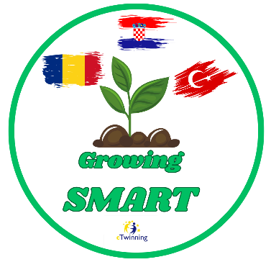 GROWING SMART 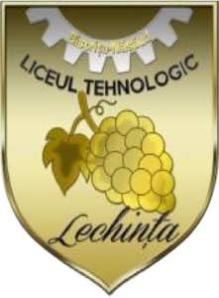
e-Twinning project
September 2025 – June 2026

Partners Croatia, Turkey, Romania
Aims
Growing Smart is an eTwinning project focused on raising ecological awareness, preserving biodiversity, and connecting natural science content with students’ digital competences. The project is based on teamwork, creativity, and interdisciplinary learning, encouraging cooperation between students, teachers, parents, and the local community. Over the course of one school year, students will construct raised garden beds using recycled materials, collect and cultivate native plant species, design interactive QR-coded cards, and develop a bilingual digital e-herbarium as the final project outcome.
LTL Team
Students – IV B Class
Bolchiș Daria- Elena Borgovan Daria- Maria
Jucan Mario Leahu Ștefan – Adrian
Raț Lorena – Florina Șimon Patrik
Șuler Tudor Răzvan Zadic David
Ziman Matei- Alexandru

Coordinator teacher
Barar Tincuța- Ionela

