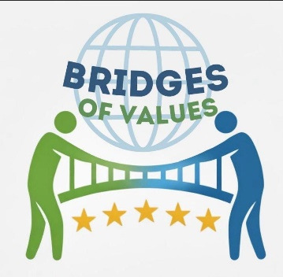 BRIDGES OF VALUES 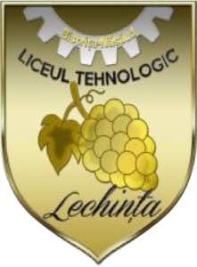
e-Twinning project
October 2025 – March 2026
Partners
Turkey, Croatia, Romania, Poland, Italy, Spain, Greece, Portugal, Serbia
Aims
Bridges of values is an international eTwinning project that aims to raise awareness among high school students about the core values of citizenship such as democracy, equality, tolerance, justice, human rights, and environmental responsibility. By combining creativity, research, and digital tools, students from different countries will collaborate to design a virtual museum that celebrates what unites us as European citizens.
LTL Team
Students
Chezan Denis- Grigore – X A
Frumos Adrian – X A
Iroveanu Ana- Maria Lorena – X A
Miclea Nicolae – Jaissan – X A
Breșfelean Bianca- Octavia – XI A
Chira Larisa – XI A
Cuc Adrian- Mihai – XI A
Imbuzan Ana- Maria – XI A

Coordinator teacher
Barar Tincuța- Ionela

